5. BREADTH FIRST SEARCH (BFS)
Aim
To implement the Breadth First Search (BFS) algorithm in Python to traverse all the vertices of a graph level by level.
Objective
- To understand the working of the BFS algorithm.
- To traverse all the nodes of a graph starting from a given source node.
- To use a queue for visiting nodes in breadth-wise order.
Algorithm
- Start.
- Create a graph using an adjacency list.
- Create an empty list for visited nodes.
- Create an empty queue.
- Read the starting node.
- Add the starting node to the visited list and queue.
- Repeat until the queue becomes empty:
  - Remove the first node from the queue.
  - Display the node.
  - Visit all its adjacent nodes.
  - If an adjacent node is not visited, add it to the visited list and queue.
- Stop.

Flow Chart:
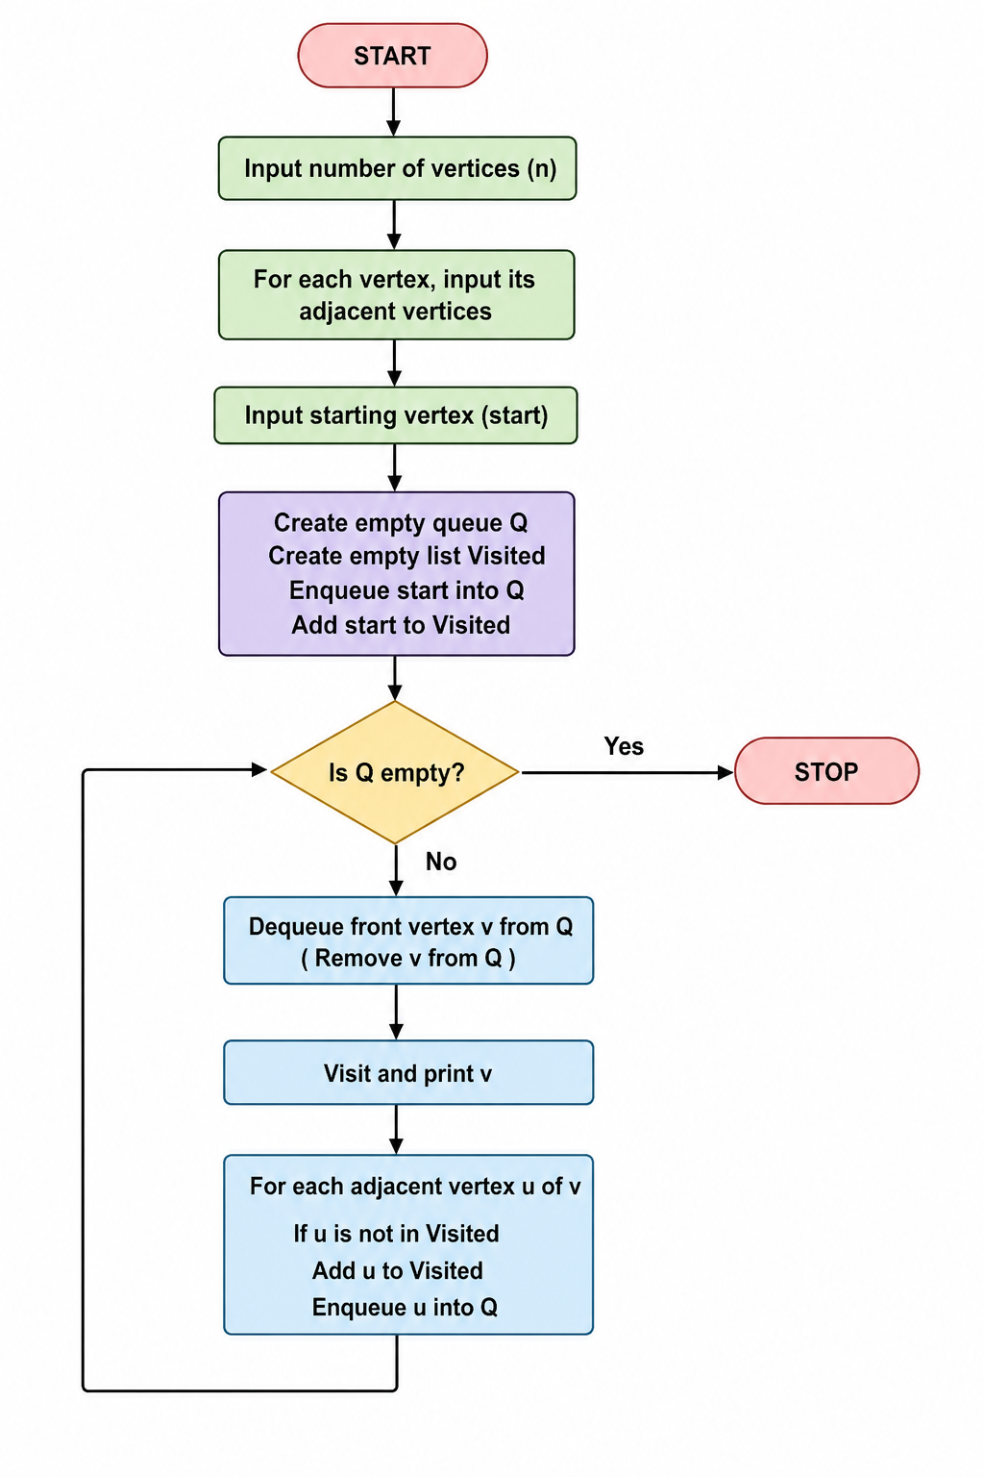

Code:
visited = []
queue = []

graph = {}

n = int(input("Enter number of vertices: "))

for i in range(n):
vertex = input("Enter vertex: ")
neighbors = input("Enter adjacent vertices (space separated): ").split()
graph[vertex] = neighbors

def bfs(start):
visited.append(start)
queue.append(start)

while queue:
node = queue.pop(0)
print(node, end=" ")

for i in graph[node]:
if i not in visited:
visited.append(i)
queue.append(i)

start = input("\nEnter starting vertex: ")
print("BFS Traversal:")
bfs(start)

Output:
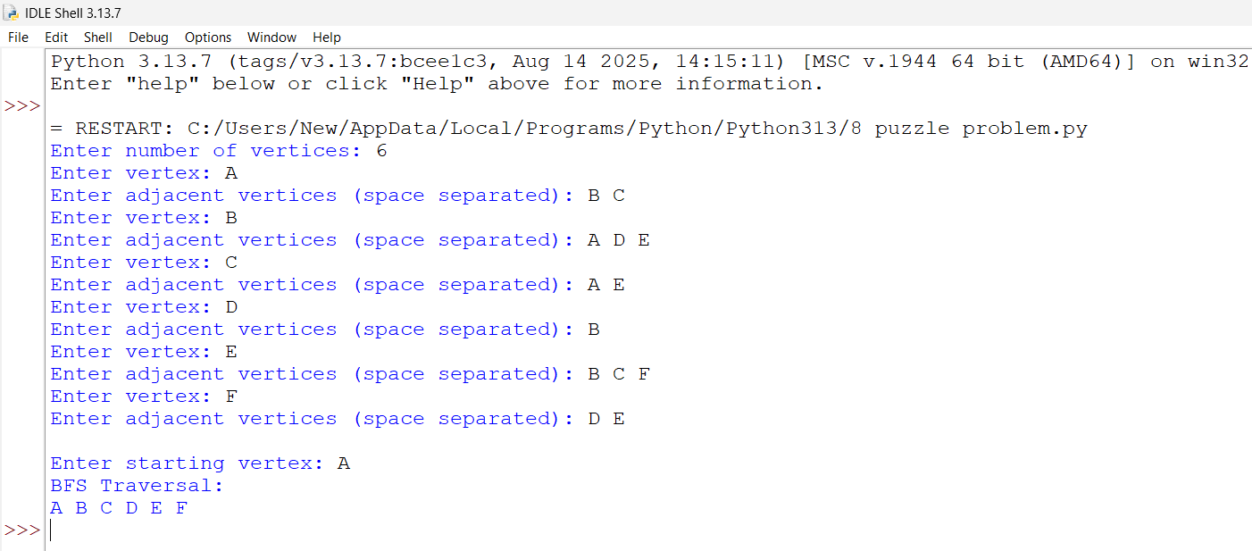Result:
The Breadth First Search (BFS) algorithm was successfully implemented in Python. The graph was traversed level by level from the given starting node using a queue, and all reachable nodes were visited successfully.

